Title [centred, Heading 1, Arial 14 Bold, before 12pt, after 0pt, line spacing: multiple 1.15]
Name FamilyName [centred, Heading 2, Arial 12 Bold-Italic, before 6pt, after 0pt, line spacing: multiple 1.15] – please provide full names, not only initials
Institution, Country [centred, Normal, Arial 11, before 6pt, after 0pt, line spacing: multiple 1.15] –universities, large research institutions... please use the format: Department, University, Country
e-mail: corresponding@author [centred, Normal, Arial 11, before 6pt, after 0pt, line spacing: multiple 1.15]
Text, text, text [justified, Normal, Arial 11, before 12pt, after 0pt, line spacing: multiple 1.15]
Text, text, text [justified, Normal, Arial 11, First line 0.5cm, before 3pt, after 0pt, line spacing: multiple 1.15]
Subtitle [aligned left, Normal, Arial 11 Bold, before 6pt, after 0pt, line spacing: multiple 1.15]
Text, text, text [justified, Normal, Arial 11, First line 0.5cm, before 3pt, after 0pt, line spacing: multiple 1.15]
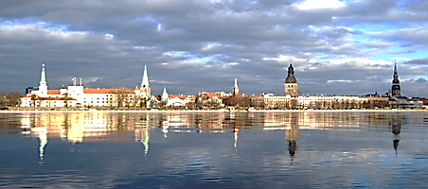
Fig. 1. Title. [centred, Normal, Arial 10 Italic, before 3pt, after 0pt, line spacing: multiple 1.15]
Table 1. Title. [centred, Normal, Arial 10 Italic, before 3pt, after 3pt, line spacing: multiple 1.15]
date | Population | Annual Change, %
1960-12-31 | 597,000 | 1.88
1980-12-31 | 840,000 | 0.96
1989-12-31 | 909,000 - maximum | 0.44
2000-12-31 | 762,000 | -1.17
2020-12-31 | 631,000 | -0.47
2035-12-31 – UN projection | 588,000 | -0.51
Acknowledgments: This research was … justified, Normal, Arial 10, before 6pt, after 0pt, line spacing: multiple 1.15]
References – example
[1] Svanberg S. (2013) Gas in Scattering Media Absorption Spectroscopy – from Basic Studies to Biomedical Applications. Lasers and Photonics Reviews 7, 779 [justified, Normal, Arial 10, Hanging 0.5cm, before 0pt, after 0pt, line spacing: single]
[2] Handbook of Silicon Photonics (2013). Vivien L., Pavesi L. (eds). CRC Press, p.849. ISNB….
[3] Atomic Spectra Database | NIST. https://www.nist.gov/pml/atomic-spectra-database

